**Database Enhancement Narrative**

The artifact I chose to enhance is a SlideShow application, originally created as part of a Java programming course in the spring semester of 2023. The initial version was a simple Java Swing application that displayed a series of travel destination images with accompanying descriptions. The slides were hardcoded into the application, limiting its flexibility and scalability.

I selected this artifact for my ePortfolio because it presented an excellent opportunity to demonstrate my skills in database integration, full-stack development, and software enhancement. The original application, while functional, lacked the robustness and flexibility required in modern software development.

I transformed the application to use MongoDB, a NoSQL database, demonstrating my ability to work with modern database systems. This involved creating a MongoDBManager class to handle all database operations, showcasing my skills in data persistence and retrieval.

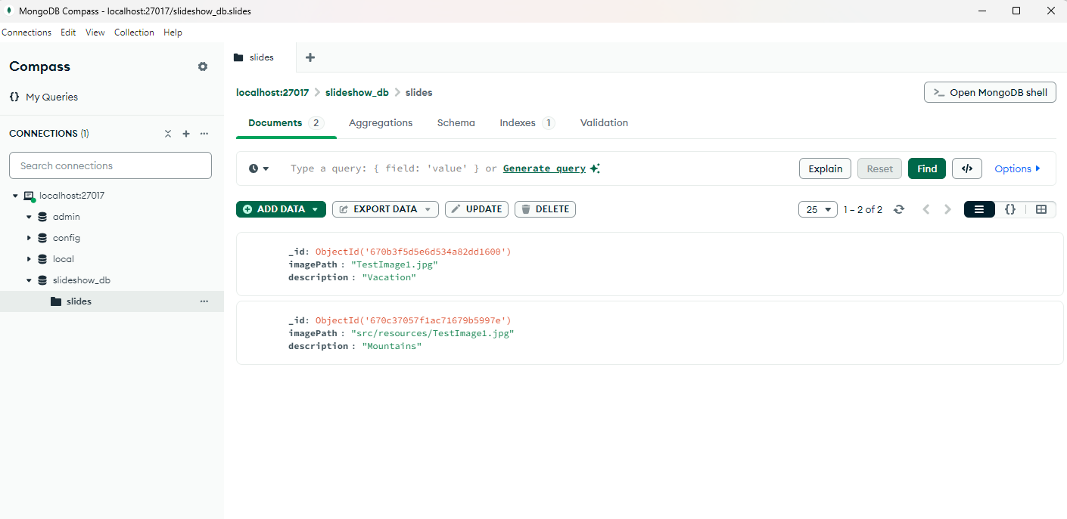

*Figure 1: MongoDB Compass showing the slides collection in the slideshow_db database*

By adding a web interface using Java Servlets and JavaScript, I demonstrated my ability to create full-stack applications. This enhancement shows my proficiency in both backend (Java) and frontend technologies, such as the use of HTML.

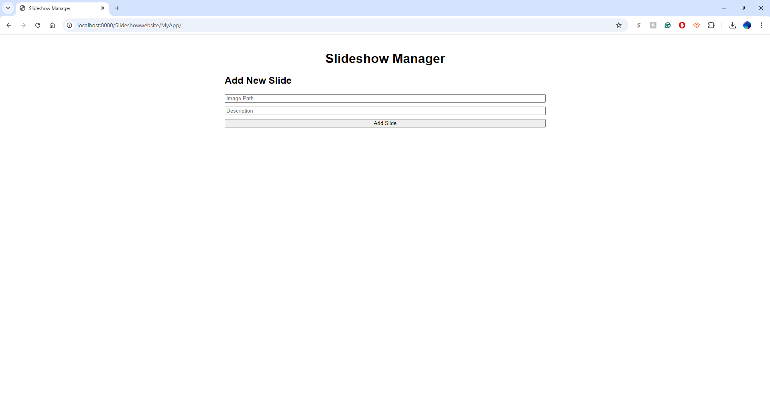

*Figure 2: Web interface for the Slideshow Manager*

The original SlideShow class was refactored to work with the new database system, demonstrating my ability to modify existing code to accommodate new features and improve overall design.

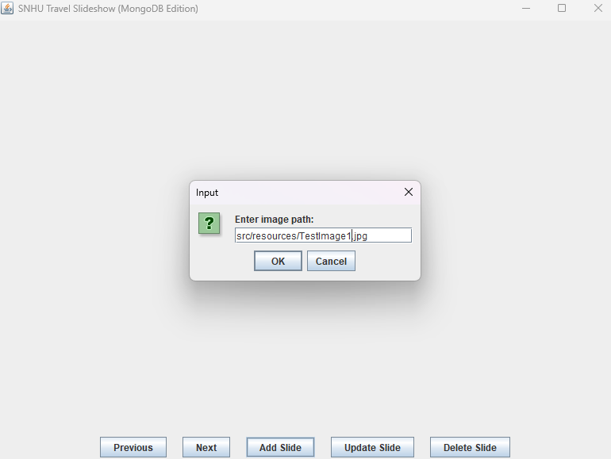

*Figure 3: Java Swing interface for adding a new slide*

The SlideManagementServlet class implements a simple RESTful API, showcasing my understanding of modern web service architectures. All classes were updated with comprehensive comments following best practices, demonstrating my commitment to writing clear, maintainable code.

The artifact was significantly improved by:

* Implementing persistent storage using MongoDB, allowing for dynamic management of slides.
* Adding CRUD (Create, Read, Update, Delete) operations for slides.
* Creating a web interface for managing slides, enhancing usability and accessibility.
* Improving code structure and documentation for better maintainability.

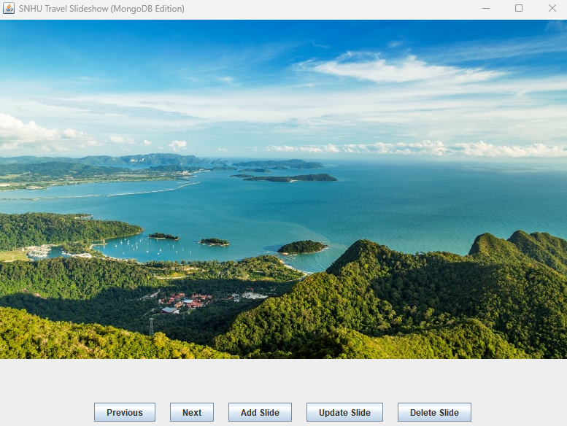

*Figure 4: Enhanced Java Swing interface displaying a slide*

This enhancement successfully met the planned course outcomes related to database integration and software development. It demonstrated my ability to design and implement database solutions, create full-stack applications, and enhance existing software systems. Moving forward, I plan to further expand my skills by implementing user authentication and authorization for the web interface, exploring cloud deployment options for the application, and maybe even incorporating automated testing to ensure code quality and reliability.

The process of enhancing this artifact was both challenging and rewarding. I learned several valuable lessons such as working with MongoDB expanded my understanding of NoSQL databases and their advantages in certain scenarios. I learned how to model data as documents and perform CRUD operations in a NoSQL context. Creating the web interface helped me understand the intricacies of connecting frontend and backend systems. I gained experience in designing RESTful APIs and handling asynchronous operations in JavaScript.

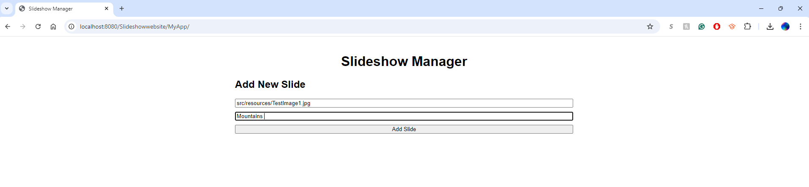

*Figure 5: Web interface demonstrating the addition of a new slide*

Also modifying the existing Java Swing application to work with a database taught me the importance of writing flexible, modular code. I learned how to refactor code to accommodate new features without completely rewriting the application. The process of adding comprehensive comments to the code reinforced the importance of clear documentation. I learned how to write effective JavaDoc comments and explain complex logic clearly.

Some of the challenges I faced consisted of initially struggling with the setup of MongoDB and its Java driver, debugging issues related to asynchronous operations in the web interface, and ensuring data consistency between the Java application and the web interface.

Overcoming these challenges improved my problem-solving skills and deepened my understanding of full-stack development and database integration. This enhanced artifact now serves as a testament to my growth as a software developer and my ability to create robust, database-driven applications.